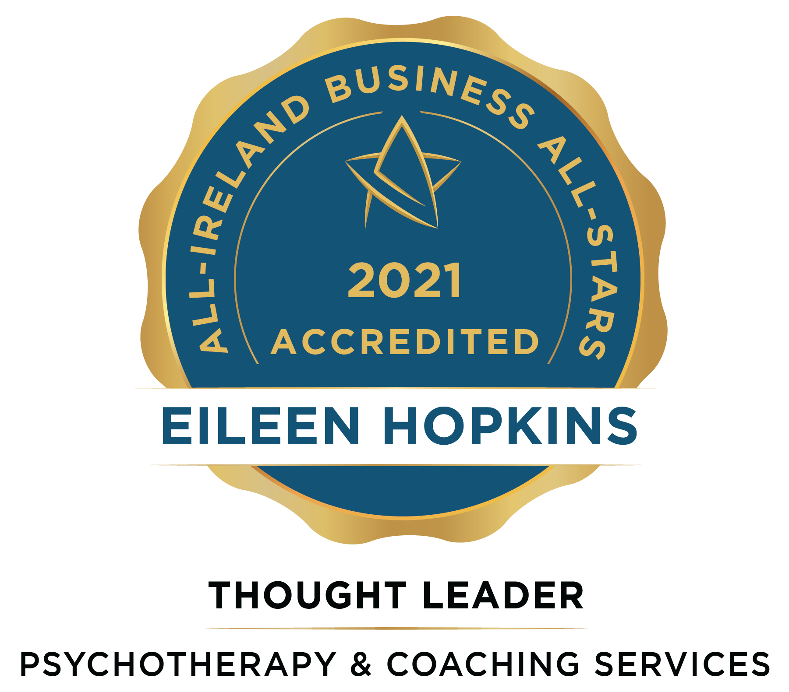

“MY MISSION IS TO MAKE A DIFFERENCE ONE PERSON AT A TIME”
_____________________________________
Eileen Hopkins achieves Thought Leader accreditation in Psychotherapy and Coaching Services from the All-Ireland Business Foundation.
---------------------------------------------------------------------------
Eileen’s mission is to make a difference, one person at a time. This journey to helping so many began in 2015 when she took early retirement from her nursing career and followed a new career path into life coaching and psychotherapy.
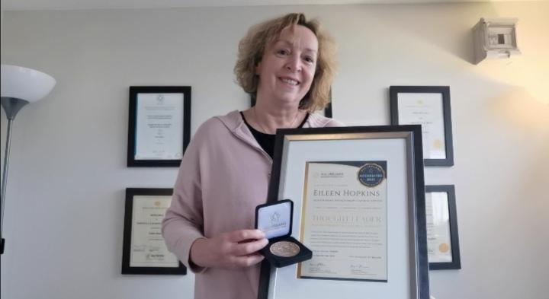
Eileen trained to be a Life Coach with the Irish Life Coach Institute, a life-changing experience for her and she followed that by training to become a psychotherapist at PCI college in Dublin. Eileen’s nursing career provided an excellent foundation for this career change as they had one common ground; she was happiest when interacting with her patients. She is hugely passionate about emotional health, providing both psychotherapy services and coaching to her many clients.

Responding to today’s announcement, Eileen Hopkins of Eileen Hopkins Psychotherapy Coaching Services says, “I am humbled, honoured and delighted to achieve this accreditation, which is a testament to my work, determination and commitment. I want to give a special mention to someone I believe has played a significant part in my success, my coach supervisor, Marian Byrne. Marian has constantly reminded me of what is possible and believed in me when I even doubted my ability. This is an incredible way to bring 2020 to a close. In just the past two weeks, I graduated from PCI college as a Psychotherapist, and I was awarded the ICF Coach of the year, a highly commended award. Thank you all for believing in me and my vision to make a difference, one person at a time”.

This is an independently verified standard mark for indigenous businesses, based on rigorous selection criteria. The accreditation is overseen by the prestigious All-Ireland Business Foundation, whose adjudication panel is chaired by Dr Briga Hynes of the Kemmy Business School at the University of Limerick and Kieran Ring, CEO of the Global Institute of Logistics.

Dr Hynes said the accreditation, which over 450 firms now hold, is needed by the thousands of small and medium businesses that operate to their own standards, but have nothing to measure them.

“We evaluate a company’s background, trustworthiness and performance, and we speak to customers, employees and vendors. We also anonymously approach the company as a customer and report back on the experience. The business goes through at least two interviews and is scored on every part of the process against set metrics”, she says.

The All-Ireland Business Foundation is a national body which accredits best-in-class Irish businesses as Business All-Stars. The Foundation also oversees the All-Ireland Business Summit while promoting peer dialogue amongst our members on an ongoing basis.

CONTACT DETAILS
Website: www.eileenhopkins.ie
Email: info@eileenhopkins.ie Phone: 0870934723

[17th December, Dublin]

